
Personal Details:

Name of the candidate: Pabani Mahanta

Fathers Name : Mr.Chhotaray Mahanta

Date of Birth : 2nd April ,2000

Mobile no. : 7846819880

E-mail ID : 21mca41@imit.ac.in

Address : Sarasaposi, Naradapur, Keonjhar
Pin-758047, Odisha

Gender : Female

Marital Status : Unmarried

Nationality : Indian

Academic Qualification :

Course Institute Board/Universsity Year Percentage

Masters in Institute of Biju Pattnaik Pursuing Awaited
Computer Management University of
Application &Information Technology
Technology

Bachelor of Anandapur North Odisha 2020 70.15%
Science College, University,
(Mathematics Anandapur, Baripada
Hons.) Keonjhar

Intermediate Panchayat Council of 2017 61.67%
Science Samiti College, Higher Secondary
Jhumpura, Education,Odisha
Keonjhar

10th Naradapur Board of Secondary 2015 66.67%
High School, Education,Odisha
Naradapur

Special Skills :

- Do my job sincerely for entire satisfaction of my higher authority.

- Persistent in achieving the set goal.

- Devoted to my work.

Technical Skill :
- C

- Java

- Javascript

Hobbies :

- Listening to both slow and loud music.

- Browsing net for new things.

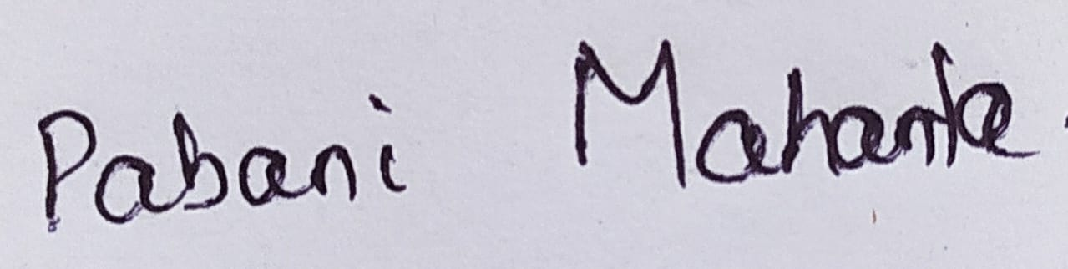
Signature

Place:-Keonjhar

